Pivot Table Cheat Sheet | Excelgraduate

Create a Pivot Table
Drill Down to Audit Data in Pivot Table
Clear, Select & Move PivotTable

Select the data range and go to Insert > Pivot Table.
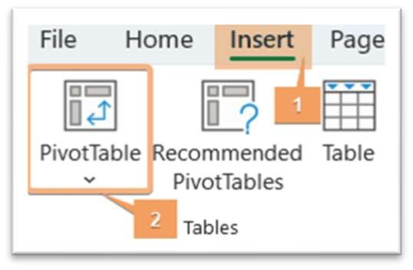
Refresh Pivot Table
Shortcut: ALT+N+V+T
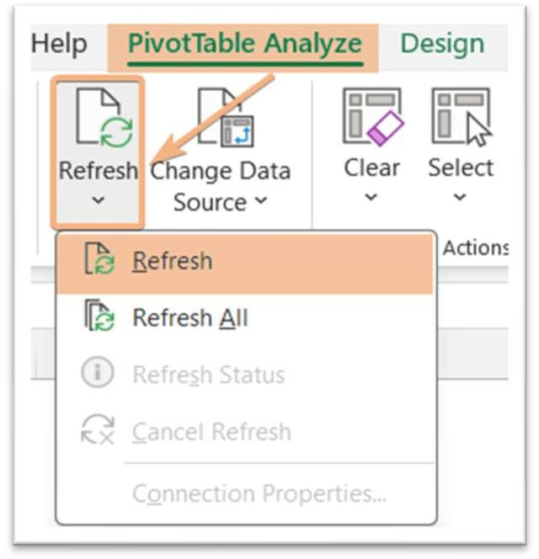
Click anywhere in the Pivot Table and go to PivotTable Analyze > Refresh. Or, right-click and select Refresh.
Double-click on a data within the Pivot Table.

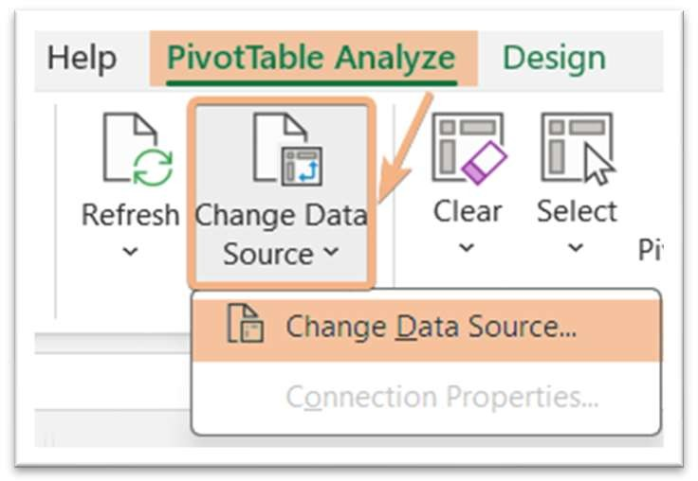
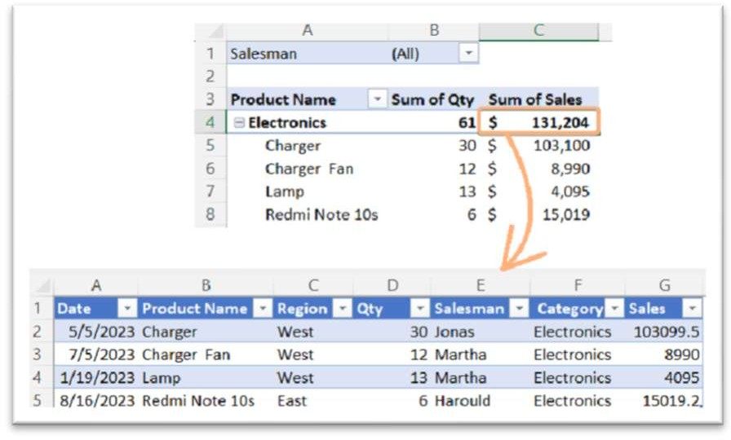Click on any cell inside the Pivot Table. Then, navigate to PivotTable Analyze > Change Data Source and select the new data range.
Change Pivot Table Range
Click a cell in the Pivot Table. Now, go to the PivotTable Analyze tab and
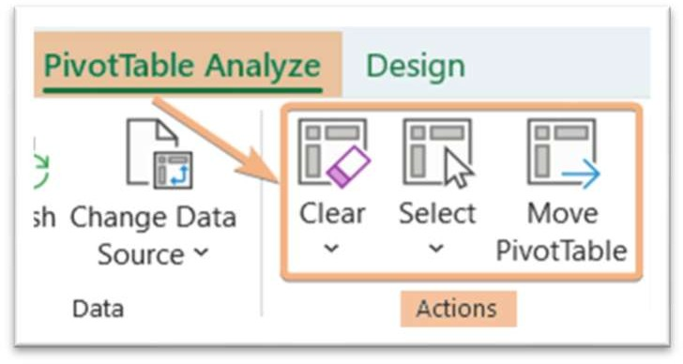
then the Actions group to access the Clear, Select, and Move PivotTable tools.

Keyboard Shortcut Keys
Clear: ALT+JT+E
Select: ALT+JT+W
Move PivotTable: ALT+JT+V
Delete a Pivot Table
Click on the Pivot Table, then go to Select > Entire PivotTable and press the
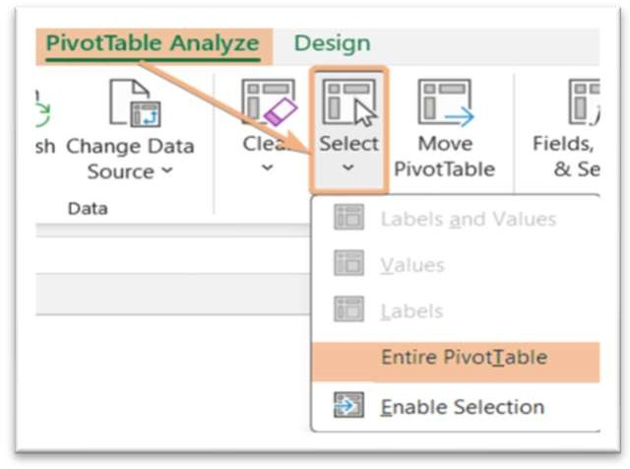
DELETE key.

Shortcut: ALT > J > T > I >D
Shortcut: ALT+F5

Shortcuts: ALT+J+W+T & press the DELETE key.

Calculated Field
Conditional Formatting in Pivot Table

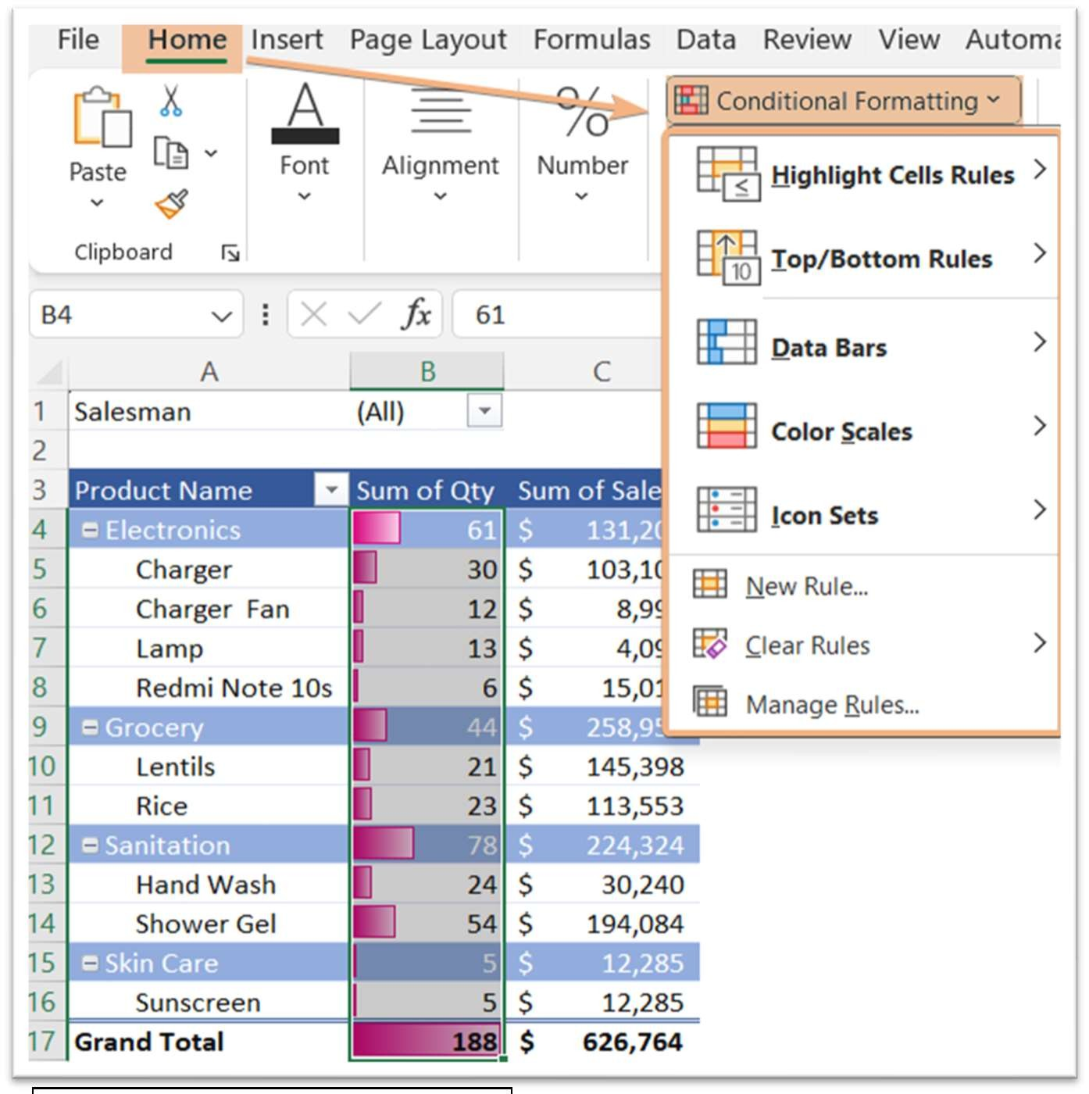Hit on a cell in the Pivot Table. Then, go to PivotTable Analyze > Fields, Items & Sets >
Shortcut: ALT > H > L

Calculated Field.
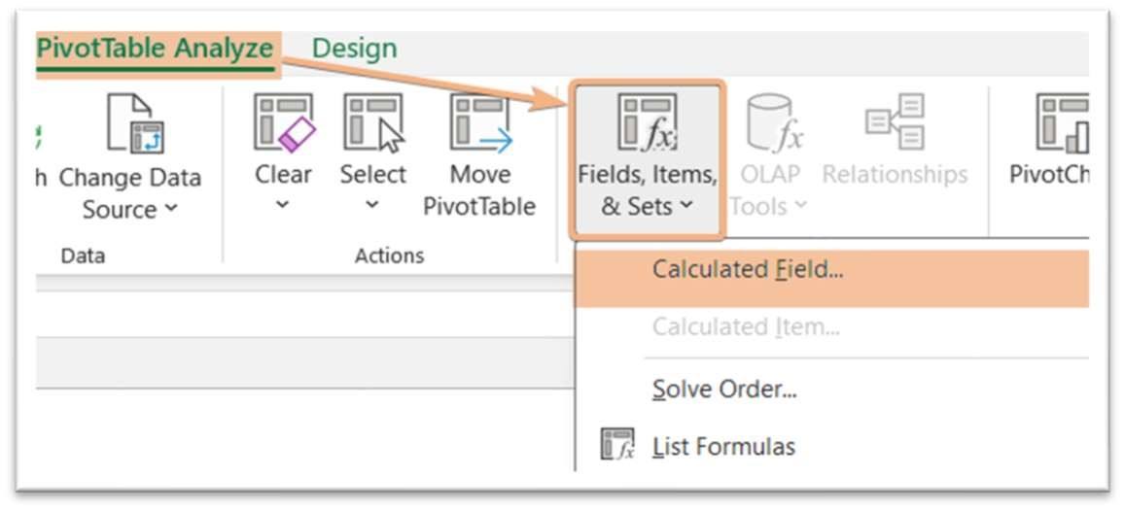

PivotTable Styles
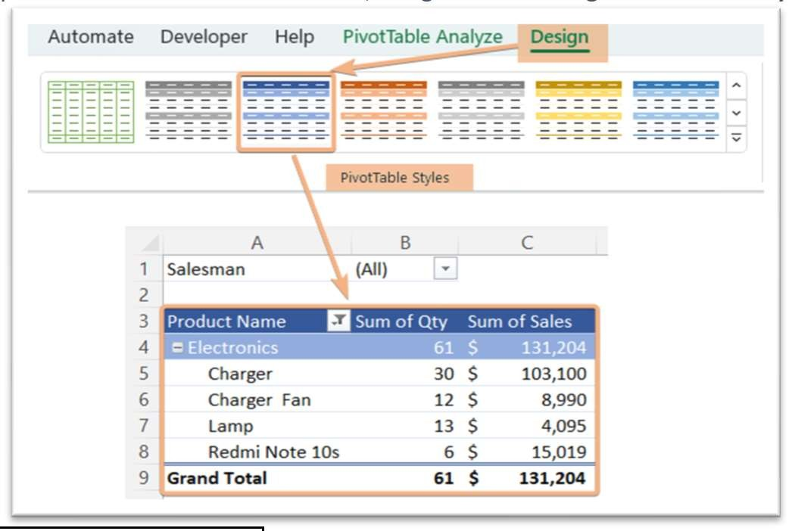Click anywhere inside the Pivot Table. Now, navigate to the Design > PivotTable Styles.
Shortcut: ALT+JY+S
To highlight values in the Pivot table, go to Home > Conditional Formatting.

Number Formatting in Pivot Table
Report Layout & Blank Rows in Pivot Table

To format value in the Pivot Table, right-click on that value and choose the Number

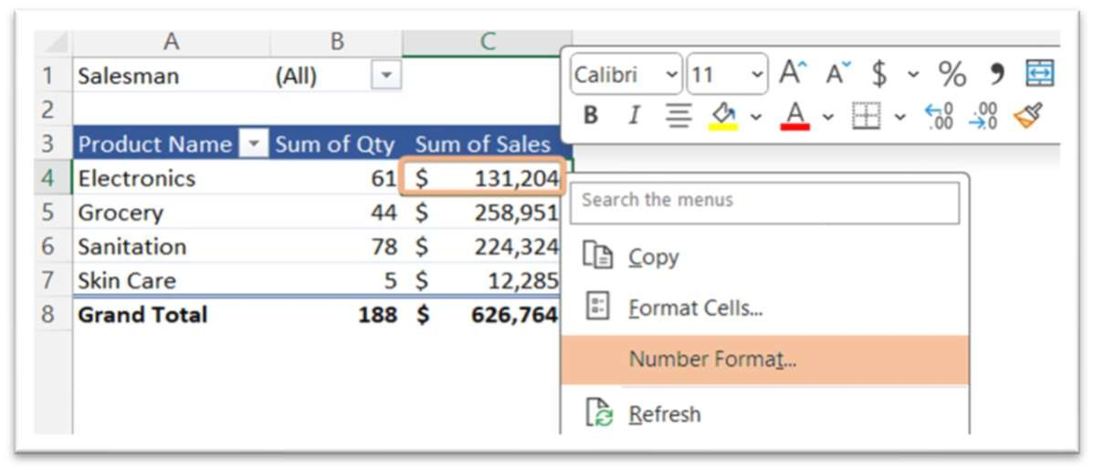
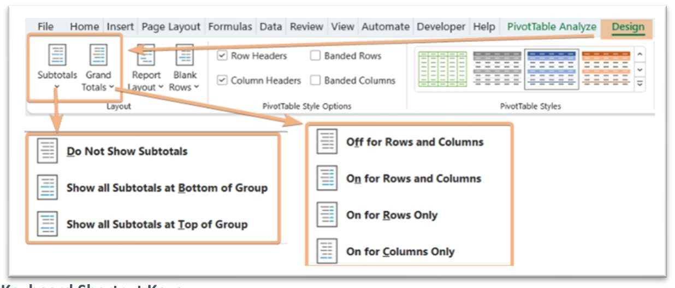
Format.

Subtotals/Grand Totals in Pivot Table
Hit a cell within the Pivot Table and go to the Design > Layout. Then, choose the options to insert or remove from Subtotals and Grand Totals.
To access Report Layout and Blank Rows, click a cell in the Pivot Table and navigate to Design >

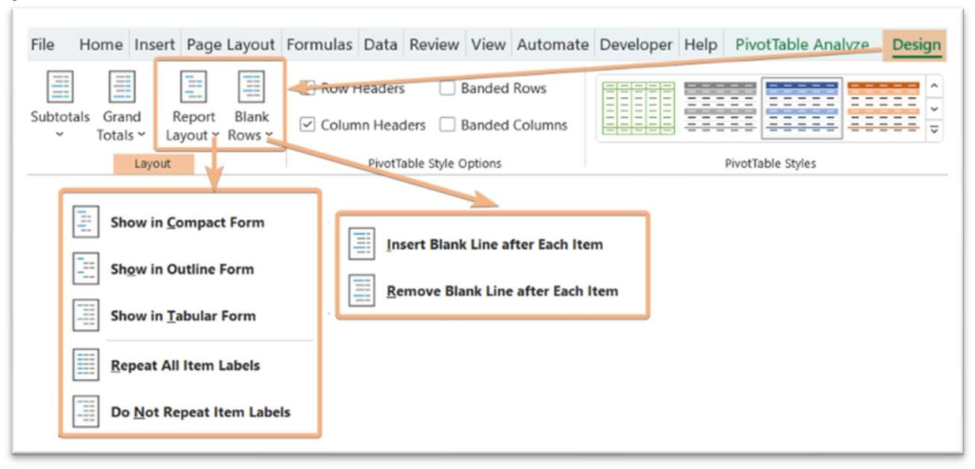
Layout.

Keyboard Shortcut Keys
Report Layout: ALT+JY+N Blank Rows: ALT+JY+P

Access PivotTable Options
Select any cell inside the Pivot Table, then right-click on that and choose PivotTable Options. Or,
after clicking on a cell, go to PivotTable Analyze > Options.

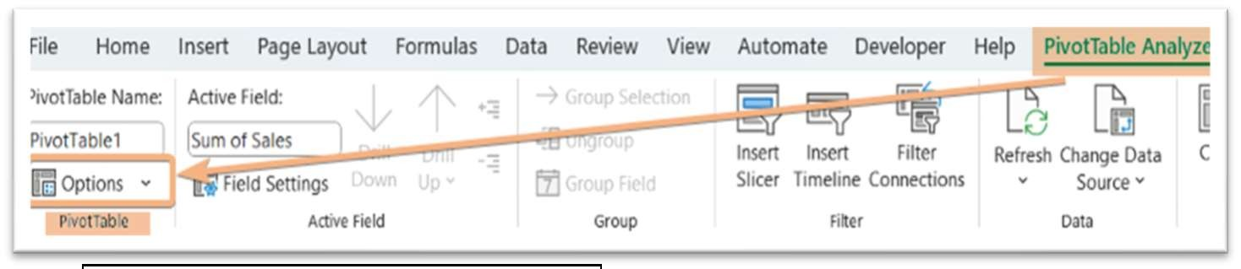Keyboard Shortcut Keys
Shortcut: ALT > JT > T > T
Subtotals: ALT+JY+F Grand Totals: ALT+JY+H

Sorting
Grouping/Ungrouping
Summarize Value as/Show Value as

Select a cell and right-click on that, then, select Sort and choose Sort

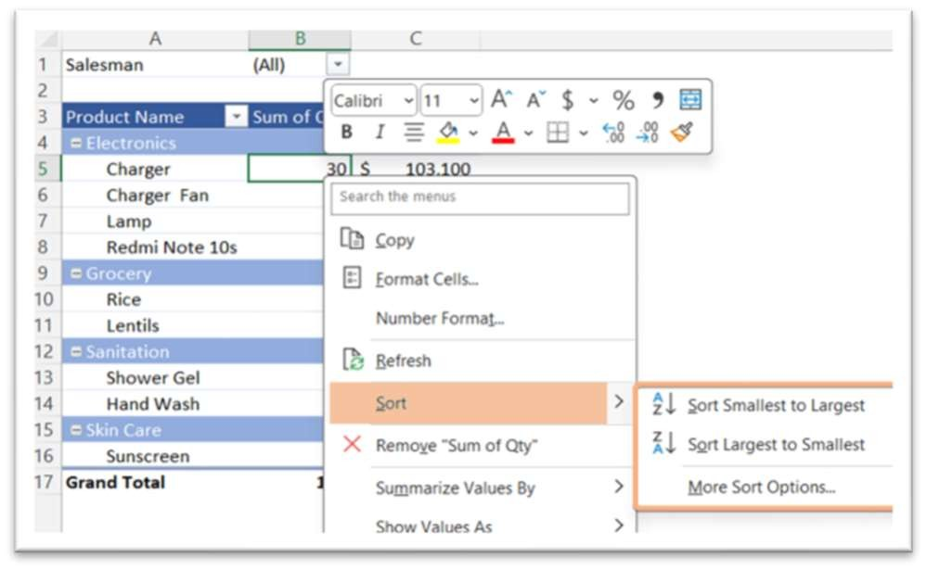
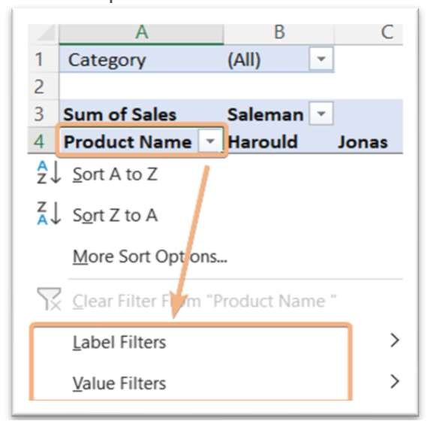
options.

Filtering
Click on the dropdown of Row Labels/Column Labels and choose Filters options in Pivot Table.
Right-click on any cell in the first column in the Pivot
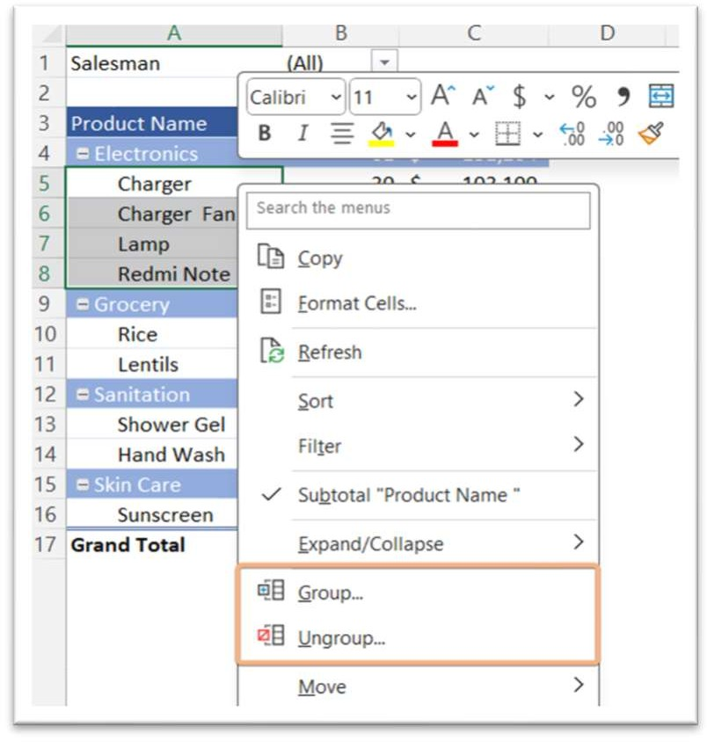Table and choose Group or Ungroup.
Insert PivotChart
Click on a cell and right-click on that, then choose

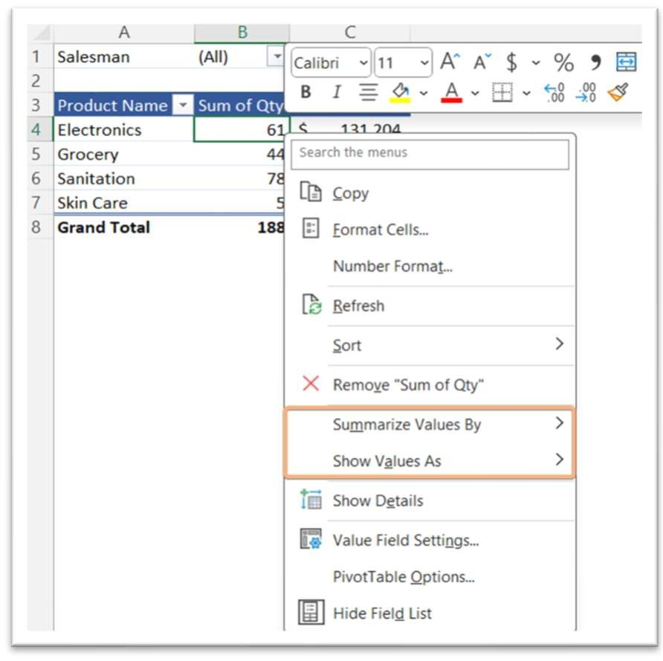
Summarize Value By or Show Value As.

Select the data range and go to Insert > PivotChart > PivotChart & PivotTable.
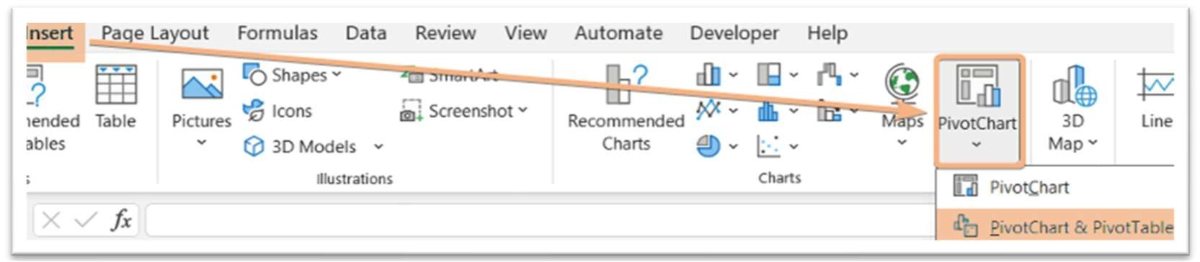

Insert Slicers
Insert Timeline

Select any cell in the Pivot Table and go to PivotTable Analyze >

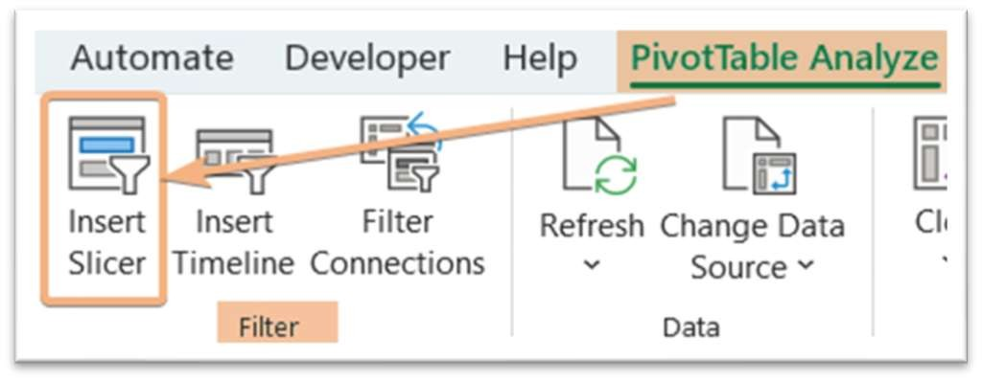
Insert Slicer.

Shortcut: ALT>JT>SF
Activate GetPivotData

Select any cell in the Pivot Table and then, navigate to the PivotTable Analyze > Options > Generate GetPivotData.
Click anywhere in the Pivot Table and go to PivotTable Analyze > Insert Timeline.
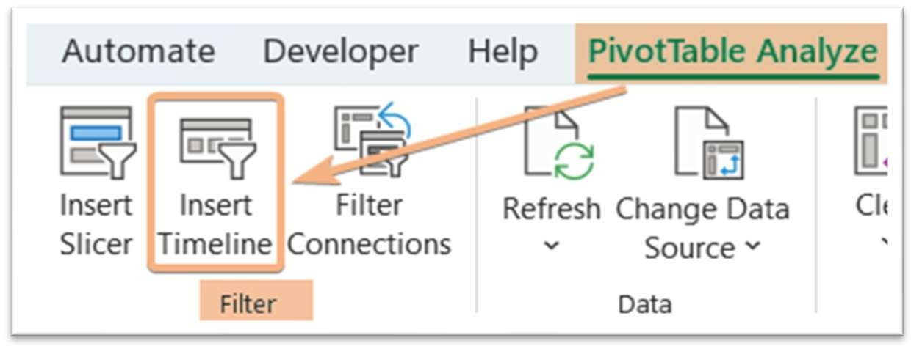

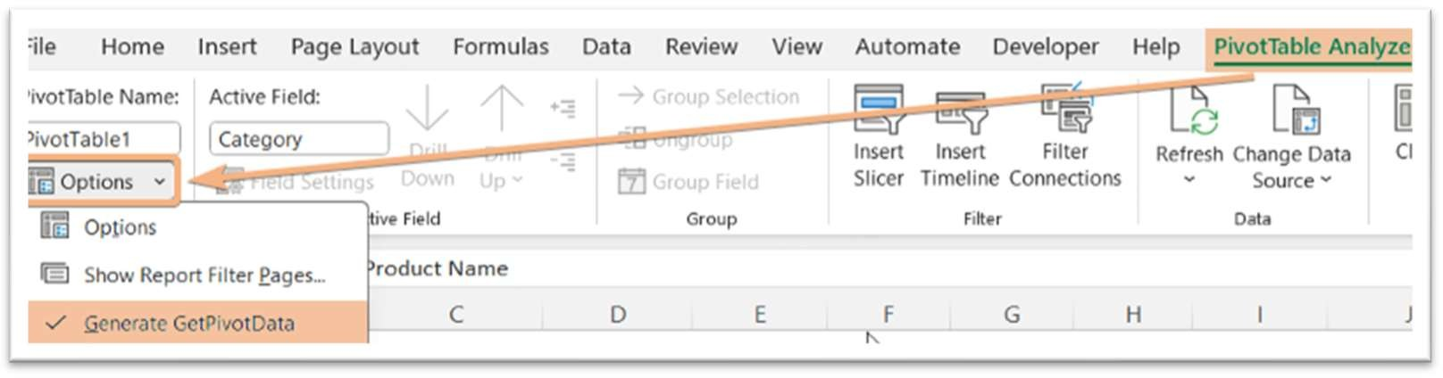
Excelgraduate
Copyright © 2023 Excelgraduate | All Rights Reserved.
Web View: https://excelgraduate.com/pivot-table-cheat-sheet/
Shortcut: ALT>JT>T>G

